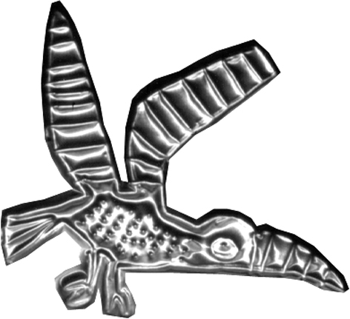
high peak community arts
Membership & Renewal Form

Please fill in your details to take up or renew membership of High Peak Community Arts – it’s free and open to anyone! To support our work further – find out about our Friends scheme…
Name |  | Are you renewing membership?
Address
Postcode | Email address:
Home or Mobile Phone
High Peak Community Arts is a membership organisation and members own our work and have the right to shape our direction.

Equal Opportunities:
High Peak Community Arts is committed to an equal opportunities policy which aims to ensure equal opportunities and fight discrimination in arts activities and services in the community, the employment of staff and within its membership and management.

Mark this box if you would like to receive occasional newsletters and invitations

I support High Peak Community Arts. SIGNED: DATE:
Digital signature is adequate if the form is returned by email to susie@highpeakarts.org

