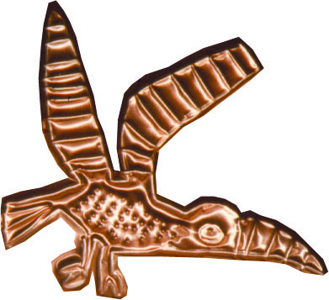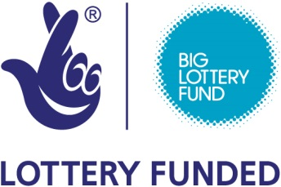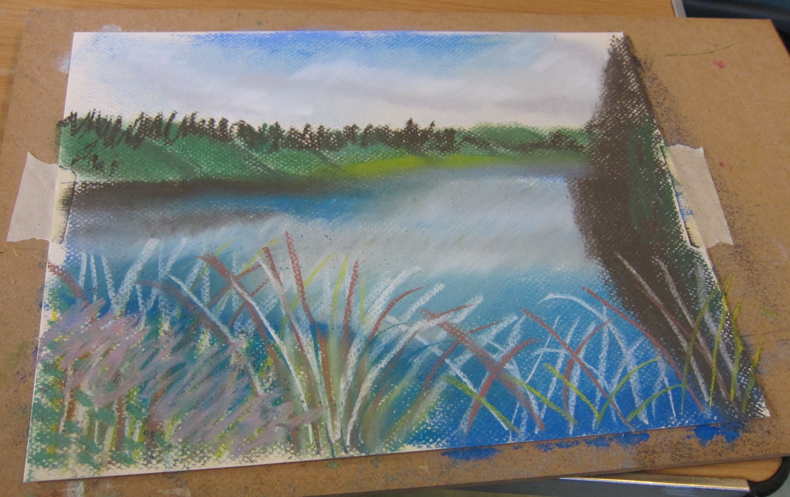

**‘Sky, Rock, Lake, Earth’**

See Project eARTh’s animated music video, created with

musician Aidan Jolly

Monday 17th July 1pm – 2.30pm

URC Church, Hardwick Square East

Buxton SK17 6PT FREE event

**high peak community arts**